FOUR POST LIFT
OPERATION MANUAL

Olympic Equipment LLC
Sales / Support: 866-774-4531 Shipping: 360-925-6622
Www.olympic-equipment.com. Email: info@olympic-equipment.com.
Four-post lift

Catalog
* Special specification
- Pay attention to the safe item ----------------------------------------------
- Characteristic introductions -----------------------------------------------
- Main technical parameters -------------------------------------------------
- Outline dimension of lift-----------------------------------------------------
- Machinery structure and working principle----------------------------
- Installation equipment and debugging-----------------------------------
- Safety----------------------------------------------------------------------------
- Lift hydraulic system-------------------------------------------------------
- Maintenance ----------------------------------------------------------------
- Exploded view with spare parts list ------------------------------------
- Troubleshooting -------------------------------------------------------------
- warranty card----------------------------------------------------------------

Special specification

- Equipment damage which in the process of shipment shall be claim by the buyer to the carrier.
- Design and manufacture have considered the safety performance. However, proper training and thorough operation can increase the safety. Not reading illustrates, shall not operate or repair the equipment.
- Identify the motor and the current state requirement of the nameplate, by professional and qualified electrician to connect.
- Products of the company to the part structure improvement without notice. On the previous sales product updates without any obligation to notify customer.
- Please carefully to read and fill in the instruction of the《warranty card》, feedback to the distributor and the company filing. As the evidence of after service. Or regard give up the enjoyment of the corresponding service power, responsible for themselves responsibility.
- Not be more than the rated lifting weight.
- Please carefully read the warning marks.

- Pay attention to the safe item：
  - Please read this specification carefully before operation; no one should be allowed to operate the machine without reading the instruction.
  - The impediments around and below the working-platform should be removed before operation.
  - When the lift is operation, couldn’t any one be allowed to stand nearby, above and below the lift or to sit inside the automobile has being lifted.
  - The weight of the vehicle being lifted can not exceed the capacity of this machine.
  - In operation，the grip brake of the automobile being lifted should be on and fix it with skid-wood to prevent from slide (self-prepared by user).
  - When four safety lock pins into the lock hole exactly，personnel can enter into the working area.
  - When the lift is out of use, should be cut off the power.
  - After a period of utilization, the steel rope will be elongated and the platform loses its plane, so that, the length of steel cable should be adjusted in time.
  - According to the instruction to maintain the machine strictly, the main parts of the machine should be overhauled regularly.
  - Fire-extinguishers are needed on spot (user-prepared)
2. Characteristic introduction：
The machine has advanced design, reasonable structure, safety and reliable performance. The hydraulic platform perform stably with lower noisy and easy to operate. The space between the vertical carling is adjustable to adapt different models，so it can be the ideal tool for vehicle maintenance and four wheel alignment and so on.
3. Main technical parameters：
Max.lifting capacity (kg) | 14000lbs
Primary lifting height（mm） | 72.83’
Power supply | 220v/380v
Power of motor | 3kw
Rated oil pressure | 18MPa
Overall length | 246.06’
Overall width | 137.8’

4. Outline dimension of lift（diagram 1、2）

5. Machinery structure and working principle:
The machine consist of post ,vertical carling,beams,steel rope pulley blocks, lifting dolly and hydraulic pump station and so on(see diagram 1、2、3）.The driving principle of platform：when it’s up, the motor drives oil pump to make hydraulic oil into below of the cylinder, the piston rod is pushed out of the cylinder by steel rope pulley block under the action of oil pressure, the work platform is pulled up Synchronously and the lifting process completed; when it’s down, open the valve of oil circumfluence pipe, and deadweight makes oil back to oil tank from the below cavity of a cylinder and the descent completed. The working principle of secondary lifting dolly is the same as the platform does.(double dolly is available according to user’s demand)
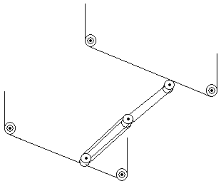
Chart 3 steel rope pulleys

6. Installation equipment and debugging：
Before installation: the instruction should be read carefully to make sure that the machine structure , any damage caused in process of loading , unloading and transportation. Accessories are if completed and then carry it out complying with the approaches as following：
- The equipment should be installed in the house with enough illumination and without dust and any pollution.
- It’s available to install the machine directly that thickness of the concrete on the ground must exceed 150mm and the level error is less than 5mm.
- Set the carling ready on site at a height of 50-100mm over ground (see chart 2), connect them to be working platform with bolts and beams, mount the lock-lever,pre-mount slide-block ,hang-board and pull out the steel cable from ends of beam separately in same time.
- Put four posts into each corresponding end of beam separately, insert the bolt at top of hang-board into the hole at the top end of post, screw the nut, meanwhile, put the bolt of steel cable through the corresponding hole of post and screw down the nut.
- Adjust the relative position and gap between post and beam, make the vertical level of the post to be a right position, and then fix the post with inflating bolt.
- Check up the steel rope and the installation of hang-board, adjust the steel rope at the top of post and the nut of hang-board to level the platform, and adjust the gap of slide-block finally.
- According to the electric principle diagram connect the wire for power supply ((prepared by user).
- Fill 10L of wearing-resisting hydraulic oil into the oil tank (oil prepared by user).The highest oil level is 10mm under the top of oil tank, and the lowest oil level is 30mm under the top of oil tank.(check it with the rule)
- Connection of pipe:
Connect the high-pressure oil pipe according to the oil pipe and connecting mode (see fig.)(Pay attention to the pipe connecter to prevent from sand and mud).
10)Load trial：
Oil the every lubricating point and side, check and adjust up-spacing switch, if it’s normal, check the oil pipe if it’s leaking and if the foundation is fastness, and then the trial begins. The first is idle work for 2-3 times, if no abnormal noisy, no leaking, the load trial is beginning for 2-3 times, if no abnormal noise and leaking, the lifting time and height corresponds with the tech-parameter, the trial is finished.
11) After the load trial, adjust the working platform again as the steel cable was elongated, and then the machine is ready to work.
7. Safety：
The safe mechanism of this machine consists of hanging board, safe lock, eccentric wheel and manual level.
- Safeguarded：Hanging board suspends vertically inside the post, the safe-lock locates at the beam, shift the lock level clockwise to lock position, now the lock-pin pressures the spring out from the quadrate hole of hang-board. When platform goes up to the necessary height, shift the lock-level counterclockwise to its off position and the lock-pin protrudes caused by the action of the spring. Working platform goes down a little; the lock-pin enters to the quadrate hole of hang-board to guarantee the platform stop at the necessary height safely so that the maintenances can be done. When working platform needs to be down, first of all, let the platform go up a little, shift the lock-level clockwise to lock position, the lock-pin disengages from the hang board caused by the action of lever. The deadweight let platform down and the process completed.
- Steel cable broken: The gemel of eccentric wheel on the beam, the idler-wheel relies onto steel cable. In action, the idler-wheel moves up and down along the steel cable, a gap exists between eccentric wheel and hang-board, when the cable was broken; the idler-wheel loses its support, and the spring makes a fast-clockwise rotating to lock the beam on the hang-board closely to prevent from the falling of the platform in effect.
Causion!Be careful swiveling direction of motor and the height of oil-level in tank
8. Lift hydraulic system:
*There are two sorts can be selected depending of the user’s demand, they are single-hydraulic system and double-hydraulic system. The primary user should pay more attention on the rotating direction of the motor in the moment of connecting wire (clockwise is right) . the running with wrong direction for a long time may cause damage to the gear pump.
*Hydraulic pump station of lift hangs onto the post(see chart 4), the connection of motor, integrated circuit, valve and cylinder could refer (see chart 5), hydraulic system principle diagram (see chart 6). Adjust over-flow valve ,it is ready in factory, its capability changes within rated range(it’s impossible higher than 18Mpa) .turn the handle of tee-ball valve to connect the system with oil cylinder of main-engine and the oil cylinder of dolly separately, and to realize up and down operation for both main engine and the dolly. Push down the handle of manual unloading valve to realize the movement of descent

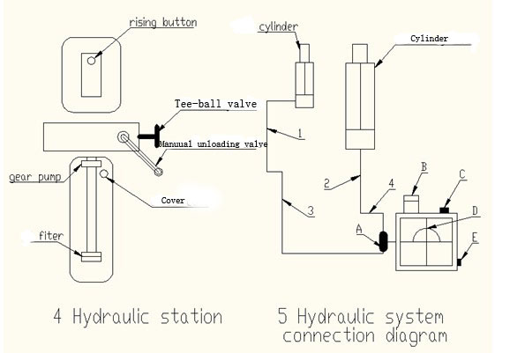

NO. | name | NO. | name
1 | High pressure hose | B | Manual unloading valve
2 |  | C | One –way valve
3 |  | D | motor
4 |  | E | Over-flow valve
A | Tee-ball valve(joint to main cylinder)

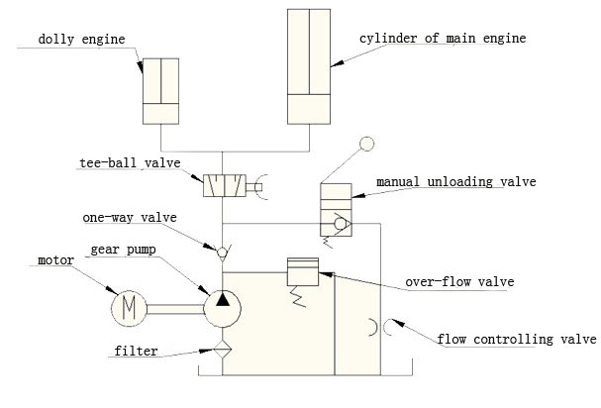9.Maintenance：
- For the new lift or restart it after blacking out long time(over 1 month),should replenish wear-resisting oil to it and keep the height of oil level well.
- Operator should check the visible part and designed part of the steel cable regularly, if one of the situations appears as following, it must be replacement with new cable in time.
  - A full strand of steel cable was broken..
  - More than 9 pieces of exterior steel wire was broken within a range of 80mm, or over 20 pieces within 350mm.
  - The exterior diameter decreased more than 15% caused by abrasion.
  - The broken pieces gather together in same strand or within a short range.
- The length of steel cable should be adjusted regularly or irregularly depending its situation to guarantee the platform to locate the lowest place and all of four cables are tensioned.
- The lock-pin of four safe locks must enter to quadrate hole of the hang-board synchronously, if it does not synchronize, the adjustment is needed to guarantee the machine a safe run.
- The filter inside of the oil tank should be cleaned out quarter-yearly, and the hydraulic oil should be replaced after 3 months for the new machine, since then the hydraulic oil will be replaced once semiannually, and the oil tank and the filter should be cleaned gasoline.
- If the local voltage fluctuation over 10%, the manostat has to be installed.
10. Exploded view with spare parts list

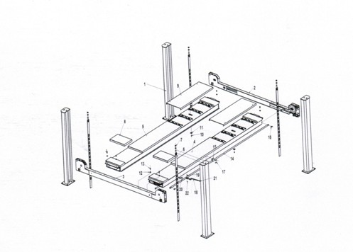

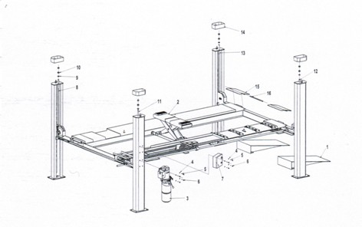

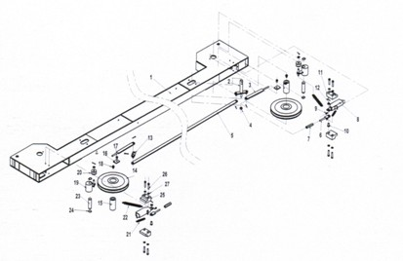

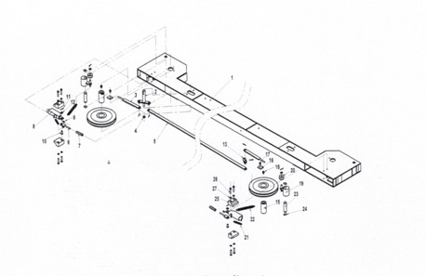

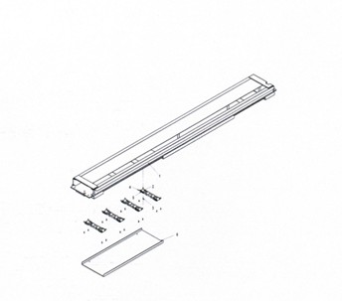
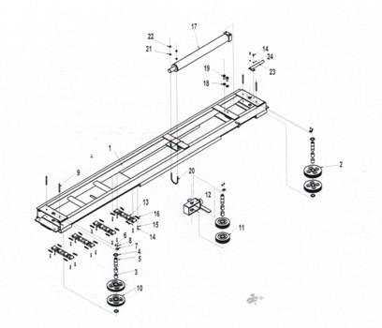
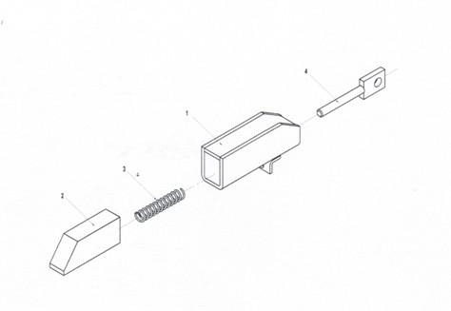

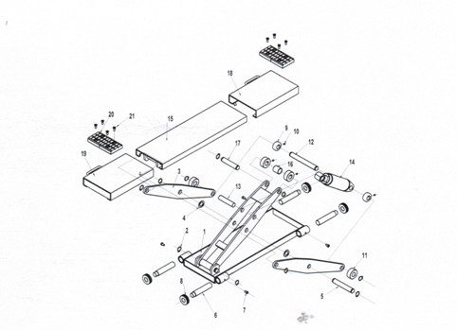

11、Troubleshooting Breakdown and solution
Breakdown | reason | Solution
Motor not work | 1、Check the fuse  2、Check the voltage normal or not  3、Motor burnout  4、Start switch burned  5、Limit switch burned | 1、Change fuse  2、Power supply to the motor by normally  3、Change the motor  4、Change start switch  5、Change limit switch
Motor work but not lift | 1、Motor reversing  2、Relief valve usually open  3、Pump suction air  4、Oil suction pipe detachment  5、Low oil level | 1、Exchange two way line  2、Change relief valve or clean  3、Tighten oil inlet pipe  4、Fastening the oil suction pipe  5、Add hydraulic oil
Lifting slowly down | 1、Check the valve whether varia or not  2、Whether oil unloading valve is blocked or not  3、Whether external oil leak or not | 1、Clean varia in the valve  2、Clean varia in the oil unloading valve  3、Repair or change
No load work but overload does not work | 1、Low voltage  2、Relief valve have varia  3、Pressure regulating valve adjustment inappropriate  4、Overload lifting | 1、Install regulator  2、Clean relief valve varia  3、Properly adjustment to the working pressure  4、As the requirement of lifting capacity.
Lifting speed slowly or oil overflow the tank | 1、Oil circuit have the air  2、Oil suction pipe have the air  3、Oil return pipe loose | 1、Drain oil and air  2、Reseal and fasten  3、Fasten oil return pipe
Lifting imbalance | 1、Have not adjustment steel rope  2、Installation imbalance of the ground | 1、Adjustment horizontal  2、Adjustment post horizontal
Can not fastening the bolt | 1、The bore is too large  2、Concrete thickness and strengthen is not enough | 1、Pouring again and drill it  2、Pouring foundation again
secure not work | 1、Insurance shaft、 pin rusts typically appears in the external damp places or cleaning zone  2、Insurance block pullback spring fracture | 1、Let lift rising to the top, between slider and the post connection part filling lubricating oil  2、Change pullback spring
12、 Warranty card
User name |  | Contact number |  | Date of purchase
Contact add
Product ID |  | Serial number |  | Invoice number
Maintenance place name |  |  |  | Warranty phone
Maintenance record card
Date | Record content | Change parts content |  |  |  | broker | appendix
 |  | Name | Model | specification | quantity
Warranty conditions
一、This card and the voice user should be stored properly，Warranty must show at the same time.
二、This equipment from the date of invoice normally to use, without overhaul and machinery parts breakdown by the factory identification indeed manufacturing due to bad, according to the provisions of the warranty time limit , by virtue of this the factory is responsible for warranty. Due to improper storage, supply voltage is not conform to it or not according to the method of instruction manual to operate etc. and other improper use of damage, it is not covered by the warranty.(this machine warranty for one year).

