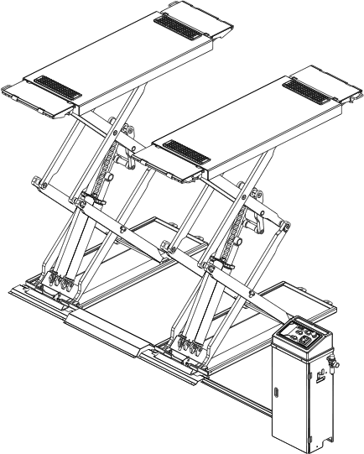
FRSL-78 Scissor Lift

Original Operation Manual

Model: ABCDE

Manufacturer: Olympic Equipment
Address:
Tel： Fax:
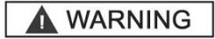
IMPORTANT SAFETY INSTRUCTIONS SAVE THESE INSTRUCTIONS

PLEASE READ THE ENTIRE CONTENTS OF THIS MANUAL PRIOR TOINSTALLATION AND OPERATION. BY PROCEEDING WITH LIFT INSTALLATION AND OPERATION YOU AGREE THAT YOU FULLY UNDERSTAND AND COMPREHEND THE FULL CONTENTS OF THIS MANUAL. FORWARD THIS MANUAL TO ALL OPERATORS. FAILURE TO OPERATE THIS EQUIPMENT AS DIRECTED MAY CAUSE INJURY OR DEATH

BE SAFE
Your new lift was designed and built with safety in mind. However, your overall safety can be increased with proper training and thoughtful operation on the part of the operator. DO NOT operate or repair this equipment without reading this manual and the important safety instructions shown inside. Keep this operation manual near the lift at all times. Make sure that ALL USERS read and understand this manual.
PRODUCT WARRANTY
Scissor lift is covered under warranty for 5 years on equipment structure, to be free of defects in material and workmanship. Power units, hydraulic cylinders, and all other assembly components (such as cables, chains, valves, switches etc.) are warrantied for one year against defects in material or workmanship under normal use. The original manufacturer shall repair or replace at its discretion, within the warranty period, those parts returned to the factory freight, prepaid, which prove upon inspection to be defective.
The warranty does not extend to:
- Defects caused by ordinary wear, abuse, misuse, negligence, shipping damage, improper installation, voltage or lack of required maintenance;
- Damages resulting from purchaser’s neglect or failure to operate products in accordance with instructions provided in the owner’s manual(s) and/or other accompanying instructions supplied;
- Normal wear items or service normally required to maintain the product in a safe operating condition;
- Any component damaged in shipment;
- Other items not listed but may be considered general wear parts;
- Damage caused by rain, excessive humidity, corrosive environments or other contaminants. THESE WARRANTIES DO NOT EXTEND TO ANY COSMETIC DEFECT NOT INTERFERING WITH EQUIPMENT FUNCTIONALITY OR ANY INCIDENTAL, INDIRECT, OR CONSEQUENTIAL LOSS, DAMAGE, OR EXPENSE THAT MAY RESULT FROM ANY DEFECT, FAILURE, OR MALFUNCTION OF PRODUCT OR THE BREACH OR DELAY IN PERFORMANCE OF THE WARRANTY.

IMPORTANT NOTICE
Do not attempt to install this lift if you have never been trained on basic automotive lift installation procedures. Never attempt to lift components without proper lifting tools such as a forklift or cranes. Stay clear of any moving parts that can fall and cause injury. These instructions must be followed to insure proper installation and operation of your lift. Failure to comply with these instructions can result in serious bodily harm and void product warranty. Manufacturer will assume no liability for loss or damage of any kind, expressed or implied resulting from improper installation or use of this product.

Content

Chapter 1 Packing, transport and storage 5
  - Package 5
  - Transport 5
  - Storage 5
  - Opening 5
Chapter 2 Description of the machine 6
  - Introduction 6
  - Intend use 6
  - Nameplate 6
  - Layout dimension 7
  - Technical parameter 8
Chapter 3 Safety caution 8
  - General warnings 8
  - Safety device 9
  - Risk list 9
  - Warning labels 11
Chapter 4 Installation 12
  - Tools required 12
  - Selecting site 12
  - Floor requirements 13
  - Platform Installation 13
  - Hydraulic system connection 13
  - Electrical system connection 14
  - Pneumatic system connection 14
  - Installation of limit switch 14
Chapter 5 Adjustment 15
  - Start 15
  - Bleeding 15
  - Checks no load 16
  - Check with load 16
Chapter 6 Operation instruction 16
Chapter 7 Maintenance 22
Chapter 8 Trouble shooting 23
Chapter 9 Disposal of used oil 25
Chapter 10 Machine demolition 26
Appendix 26
- Electrical diagram 26
- Hydraulic diagram 27
- Pneumatic diagram 28

- EC Declaration of Conformity 错误！未定义书签。

Chapter 1 Packing, transport and storage

ALL PACKING, LIFTING, HANDLING, TRANSPORT AND UNPACKING ORERATIONS ARE TO BE PERFORMED EXCLUSIVELY BY EXPERT PERSONNEL WITH KNOWLEDGE OF THE LIFT AND THE CONTENTS OF THIS MANUL.

Package
The dimension of package, please see below, and the package weight is 800kg,

Transport

Packing can be lifted or moved by lift trucks, cranes or bridge cranes. In case of slinging, a second person must always take care of the load, in order to avoid dangerous oscillations.
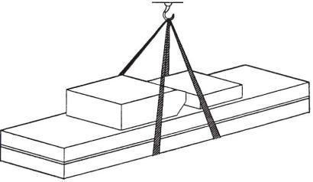
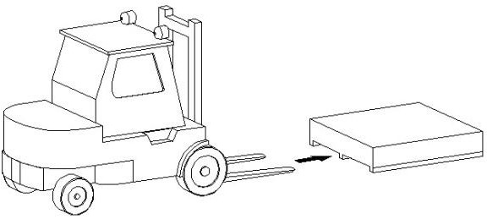
During loading and unloading operation, goods must be handled by vehicles or ships. At the arrival of the goods, verify that all items specified in the delivery notes are included. If finding missing parts, possible defects or damage due to transport, one should examine damaged cartons according to ‘Packing List’ to verify the condition of damaged goods and missing parts, also the person in charge or the carrier must be immediately informed. The machine is heavy goods! Don’t take manpower load and unload and transporting way into consideration, the safety of working is important. Furthermore, during loading and unloading operation goods must be handled as shown in the picture
Handled by crane Handled by fork-lift truck

Storage
-The machine equipment should be stocked in the warehouse, if stocked outside should do the disposal well of waterproof.
-Use box truck in the process of transport, use container storage when shipping.
-The control box should be placed perpendicularly during the transport; and prevent other goods from extrusion.
-The temperature for machine storage: -25ºC-- 55ºC

Opening
When the crates arrive, check that the machine has not been damaged during transport and that all parts listed are present. The crates must be opened using all possible precautionary measure to avoid damaging the machine or its parts. Make sure that parts do not fall from the crate during

opening.

Chapter 2 Description of the machine

Introduction
Scissor-type Lifter adopts the scissor-type mechanical structure; utilize the hydraulic pressure to produce the lifting power. The air pressure controls the lock and loosening of the execution components. The mechanical lock could insure the security and the hydraulic balance valve adjust the lifting flat level. It possesses many advantages, such as simple structure, advanced technology, easy operation, and safety. It is especially suitable for high precision wheel alignment and Auto’s repair and maintenance. The features as below:
1）The minimum height only 110mm,ground and underground installation . 2）Pressure control safety mechanical lock assure safety operation
- Equipped with emergency decline manual pump interface, can land vehicles with manual pump in case power cut.
- The photo sensor has been installed to keep two platforms in the same level.

Intend use
This scissor vehicle lift can lift various vehicles which weight is less than 4000kg. And it is suitable for vehicle test, repair, maintenance and care.
This lift is designed to lift vehicles, not for other usage.
- Forbid to use for washing and spraying vehicles!
- Forbid to lift vehicle which weight is over 4000kg
- Forbid to park car.

Nameplate

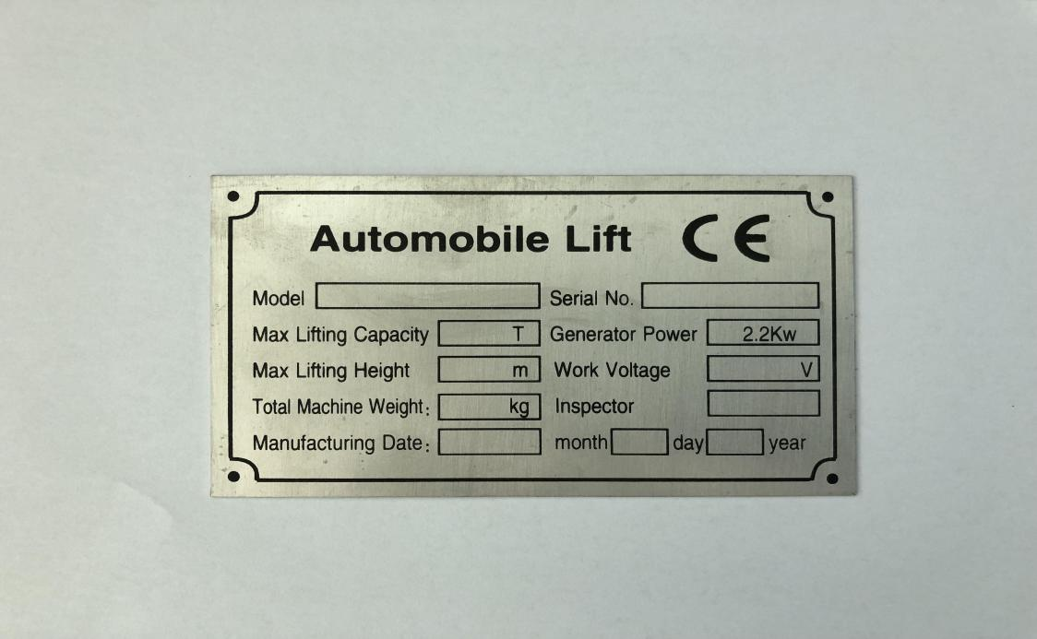

Layout dimension
Nameplate

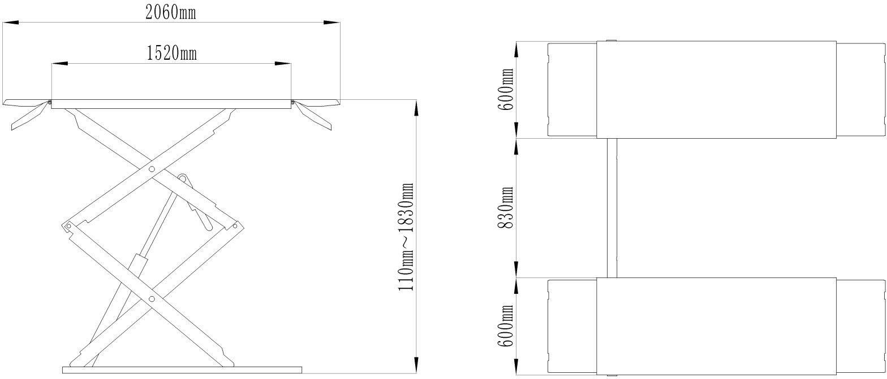

Technical parameter

Model type
Capacity | 3500kg
Max. lifting height | 1800mm
Platform initial height | 110mm
Platform length | 1520mm
Platform width | 600mm
Lifting time | ≤50s
Descent time | ≤60s
Whole machine length | 2060mm
Whole machine width | 2030 mm
Weight | 680kg
Power supply
Power | 2.2 KW
Noise | ≤70dB
Installation place | Indoors
Weight

Chapter 3 Safety caution

Read this chapter carefully and completely because it contains important information for the safety of the operator and the person in charge of maintenance.
The lift has been designed and built for lifting vehicles and making them stand above level in a closed area any other use is forbidden.
The manufacturer is not liable for possible damages to people, vehicles or
objects resulting from an improper or unauthorized use of the lift.

For operator and people safety, a square space for a safety area at least 1m free away from the lift must be vacated during lifting and lowering. The lift must be operated only from the operator’s control site in this safety area.
Operator’s presence under the vehicle, during working, is only admitted when the vehicle is lifted and the safety lock is engaged.
Never use the lift when safety devices are off-line. People, the lift and the vehicles lifted can be seriously damaged if these instructions are not followed.

General warnings
The operator and the person in charge of maintenance must follow accident-prevention

laws and rules in force in the country where the lift is installed. They also must carry out the following:
    - Neither remove nor disconnect hydraulic, electric or other safety devices;
    - Carefully follow the safety indications applied on the machine and included in the manual;
    - Observe the safety area during lifting;
    - Be sure the motor of the vehicle is off, the gear engaged and the parking brake put on;
    - Be sure only authorized vehicles are lifted without exceeding the maximum lifting capacity;
    - Verify that no one is on the arms during lifting or standing.

Safety device
To avoid overloading and possible breaking, the following safety devices have been used:
- A maximum pressure valve is placed inside the hydraulic unit to prevent excessive weight.
The maximum pressure valve has been preset by the manufacturer to a proper pressure. DO NOT try to adjust it to overrun the rated lifting
capacity.

- A mechanical safety mechanism is built inside each side with automatic engagement.
It is strictly forbidden to modify any safety device. Always ensure the safety device for proper operation during the service.

Risk list
Risks for personnel
This heading illustrates potential risks for the operator, maintenance fitter, or any other person present in the area around the lift, result from incorrect use of the lift.

Risk of crushing
Possible if the operator controlling the lift is not I the specified position at the control panel. When the platforms (and vehicle) are lowering the operator must never be partly or completely underneath the movable structure. Always remain
in the control zone.

Risk of crushing (personnel)
When the platforms and the vehicle are lowering personnel are prohibited from entering the area beneath the movable parts of the lift. The lift operator must not start the maneuvers unit it has been clearly established that there are no person
in potentially dangerous positions.

Risk of impact
Caused by the parts of the lift or the vehicle that is positioned at head height.

When, due to operational reasons, the lift is stopped at relatively low elevations personnel must be careful to avoid impact with parts of the machine not marked with special colors.

Risk of vehicle moving
Cause by operations involving the application of force sufficient to displace the vehicle. In the case of large or particular heavy vehicles, sudden movement could create an unacceptable overload or uneven load sharing. Therefore, before lifting the vehicle and during all operations on the vehicle, make sure that it is properly topped by the hand brake.

Risk of vehicle falling from lift
This hazard may arise in the case of incorrect positioning of the vehicle on the platforms, incorrect stopping of the vehicle, or in the case of vehicles of dimensions that are not compatible with the capacity of the lift.

Never attempt to perform tests by driving the vehicle while it is on the platforms Never leave objects in the lowering area of the movable parts of the lift.

Risk of slipping
Cause by lubricant contamination of the floor around the lift. The area beneath and immediately surrounding the lift and also the platforms must be kept clean.
Remove any oil spills immediately. When the lift is fully down, do not walk over
the platforms or the cross-pieces in places that are lubricated with a film of grease for functional requirements. Reduce the risk of slipping by wearing safety shoes.

Risk of electric shock
Risk cause by electric shock in areas of the lift housing electrical wiring.
Do not use jets of water, steam solvents or paint next to the lift, and take special care to keep such substances clear of the electrical control panel.

Risks related to inappropriate lighting
The operator and the maintenance fitter must be able to assure that all the areas of the lift are properly and uniformly illuminate compliance with the laws in force in the place of installation.

Risk of component failure during operation
The manufacturer has used appropriate materials and construction techniques in relation to the specified use of the machine in order to manufacture a reliable and
safe lift. Note however, that the lift must be used in conformity with manufacturer’s prescriptions, and the frequency of inspections and maintenance works recommended.

Risk related to improper use
Persons are not permitted to stand or sit on the platforms during the lift man oeuvre or when the vehicle is already lifted.
The handling of safety devices is strictly forbidden.
Never exceed the maximum carrying capacity of the lift, make sure the vehicles to be lifted have no load.
It is therefore essential to adhere scrupulously to all regulations regarding use, maintenance and safety contained in this manual.

Warning labels
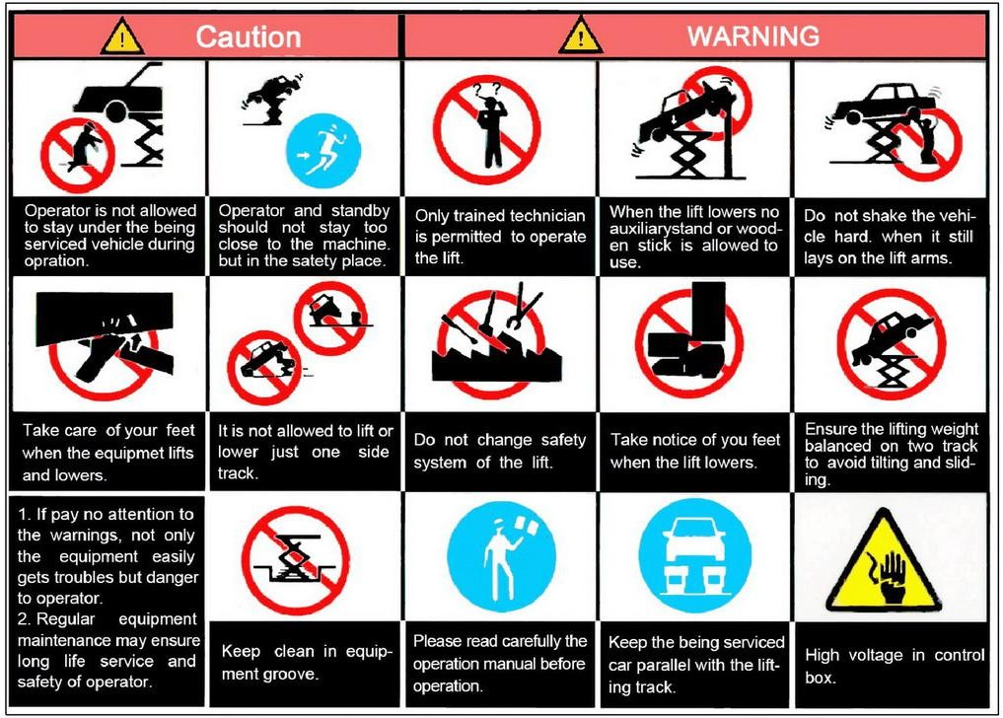
All safety warning signs displayed on the machine are with the purpose to draw the operator’s attention to dangerous or unsafe situations. The labels must be kept clean and they have to be replaced if detached or damaged. Read the meaning of the labels carefully and memorize it.

Chapter 4 Installation
Only skilled technicians, appointed by the manufacturer, or by authorized dealers, must be allowed to carry out installation. Serious damage to people and to the lift can be caused if installations are made by unskilled personnel. Always refer to the exploded views attached during installation

Tools required
- Rotary Hammer Drill or Similar  3/4” Masonry Bit
- Hammer  4 Foot Level
- Medium Pipe Wrench  Crow Bar
- Open-End Wrench Set: SAE/Metric  Chalk Line
- Socket And Ratchet Set: SAE/Metric  Crow Bar
- Hex-Key / Allen Wrench Set  Medium Flat Screwdriver
- Tape Measure: 25 Foot Minimum  Needle Nose Pliers
Important notice
These instructions must be followed to insure proper installation and operation of your lift. Failure to comply with these instructions can result in serious bodily harm and void product warranty. Manufacturer will assume no liability for loss or damage of any kind, expressed or implied, resulting from improper installation or use of this product. Please read entire manual prior to installation

Selecting site
Before installing your new lift, check the following.
- LIFT LOCATION: Always use architectural plans when available. Check the layout dimension against the floor plan requirements making sure that adequate space is available.
- OVERHEAD OBSTRUCTIONS: The area where the lift will be located should be free of

overhead obstructions such as heaters, building supports, electrical lines etc.
- DEFECTIVE FLOOR: Visually inspect the site where the lift is to be installed and check for cracked or defective concrete.
- Your new scissor lift is designed for INDOOR INSTALLATION ONLY.

Floor requirements
The lift MUST be installed on 3000 PSI concrete with the minimum thickness 150mm and an extension of at least 1.5m from anchoring points. New concrete must be adequately cured by at least 20 days minimum.
DANGERS
DO NOT install or use this lift on any asphalt surface or any surface other than concrete. DO NOT install or use this lift on expansion seams or on cracked or defective concrete.
DO NOT install or use this lift on a second / elevated floor without first consulting building architect.

Platform Installation
-Place two platforms on the position of the location.
-The bottom of oil cylinder is located in the frontage of machine (the direction of getting on the vehicle)
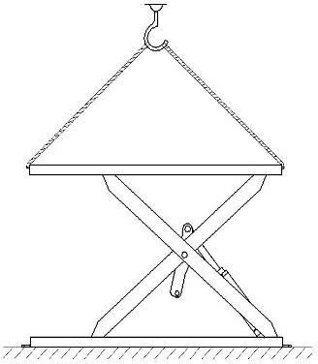
-Use fork car or other lifting equipments to lift the platform (see below picture) and make sure that the safety equipment of machine is both turned on and locked
To avoid failure of machine safety equipment, can insert a wood in the middle part of joint-pole. Prohibit working beneath the lift when hydraulic system is not completely
equipped with hydraulic oil and take the action of up and down operations.

-When moving the lift platform, adjust the space between two platforms; make sure that the two platforms are parallel.

Hydraulic system connection
  - Connect hydraulic hoses referring to below picture
  - Tighten fittings thoroughly.

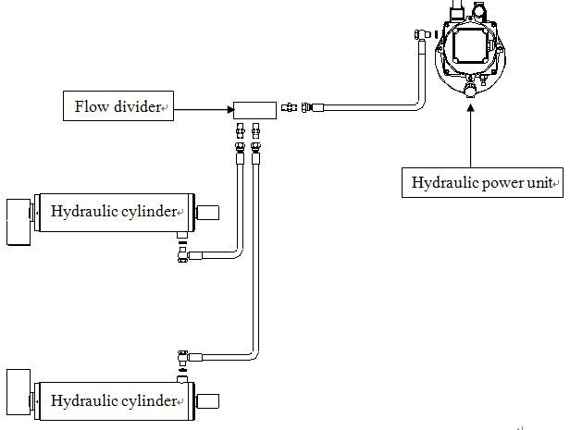

Electrical system connection
Circuit wiring must be done by a professional electrician
Make sure power supply voltage is the same as the lift requirement
Ensure the phase connection is correct the wrong wiring will burn out the motor which is not in the scope of warranty. Power unit much be keep dry

According to the circuit wiring diagram, connect the wire with control box.

Pneumatic system connection
When routing the pneumatic line, make sure that the line is clear of any moving part. Failure to do so may result in safety lock failure which may result in damage or personal harm.

The pneumatic supply at site (to which the pneumatic system of the lift is connected) must be equipped with a servicing unit composed of water separator, lubricator and pressure reducer. These devices can be supplied by the manufacturer on request.

For the connection of the pneumatic lines proceed as follow:
- Connect the pneumatic lines pre-assembled on the lift to the solenoid air valve in the control unit according to the pneumatic diagram;
- Connect the pneumatic system of the lift to the pneumatic supply at site;
- Check the pneumatic control operations for proper performance.

Installation of limit switch
- Fix the limit switch onto the base platform.

- Raise the lift at a height of 1830mm to check for the proper function;
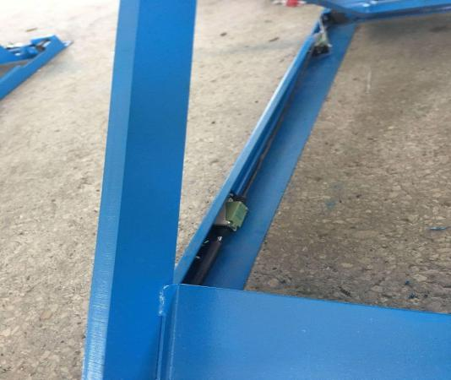
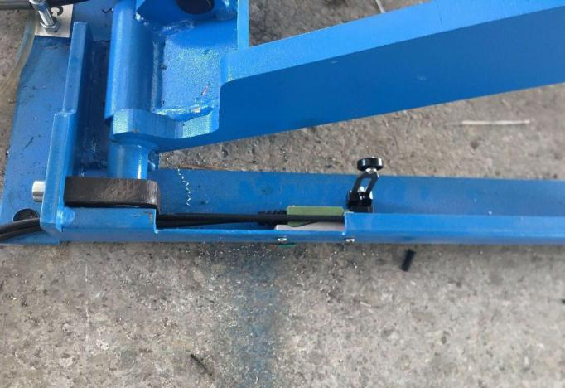
- If the switch is not functioned properly, adjust the position of the switch lever.
Top limit switch The second limit switch

Chapter 5 Adjustment

Start
- Make sure all pins and bolts to insure proper mounting
- Make sure the electrical system feeding voltage is equal to that specified in the nameplate on the motor
- Make sure the electric connections are in compliant with the electrical diagram.
- Make sure no leakage or blow-up in hydraulic line
- Make sure the working area is free from people and objects
- Grease sliding seats of blocks placed under platforms and on bases
- Pour oil in the tank (about 5 liters more then one time)
- Verify that the control unit is powered
- Verify that the motor direction of rotation is that shown on the label by pushing UP button. If motor gets hot or sounds peculiar, stop immediately and recheck the electric connections

Bleeding
- Raising the lift slowly by pressing UP button until cylinders bottom out and the lift stops. DO NOT continue pressing button after lift reaches full height. Damage to motor can occur if continued.
- Cylinders may jump upon initial start up which is normal due to trapped air inside the hydraulic lines. In case that the lift cannot be raised upon initial start up due to trapped air inside the pump: unloose the maximum pressure valve, in-push the UP button and retighten the valve after trapped air has escaped, then raise the lift at full height.
- Lower the lift completely.

- Repeat raise and lower the lift completely at least 3 times to equalize the oil pressure in each cylinder.

Checks no load
Carry out two or three complete cycles of lowering and lifting and check:
- the safety devices for proper operation
- proper oil level in the tank
- no leakage and blow-by in hydraulic line and pneumatic line
- cylinder for proper operation
- the lift for reaching its maximum height

Check with load
WARNING: Please follow carefully the instructions in the coming paragraph for avoiding damages on the lift.
Carry out two or three complete cycles of lowering and lifting and check:
- Repeat the 5.3 section , and check no strange noise during lifting and lowering

Chapter 6 Operation instruction

Lift operation by authorized personnel over 18 years only. Apply the parking brake after positioning the vehicle on the lift.
Do not allow anyone to stay in lift area during raising and lowering cycles. Closely watch the vehicle and the lift during raising and lowering cycles.
Observe the rated load capacity and load distribution.
Do not allow anyone to climb on lift or stay inside vehicle.
After raising the vehicle briefly, stop and check adapters for secure contact. Make sure the vehicle doors are closed during raising and lowering cycles.
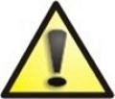
In case of defects or malfunctions such as jerky lift movement or deformation of the superstructure, support or lower the lift immediately. Turn off the power. Contact qualified service personnel.

  - Control
Control panel

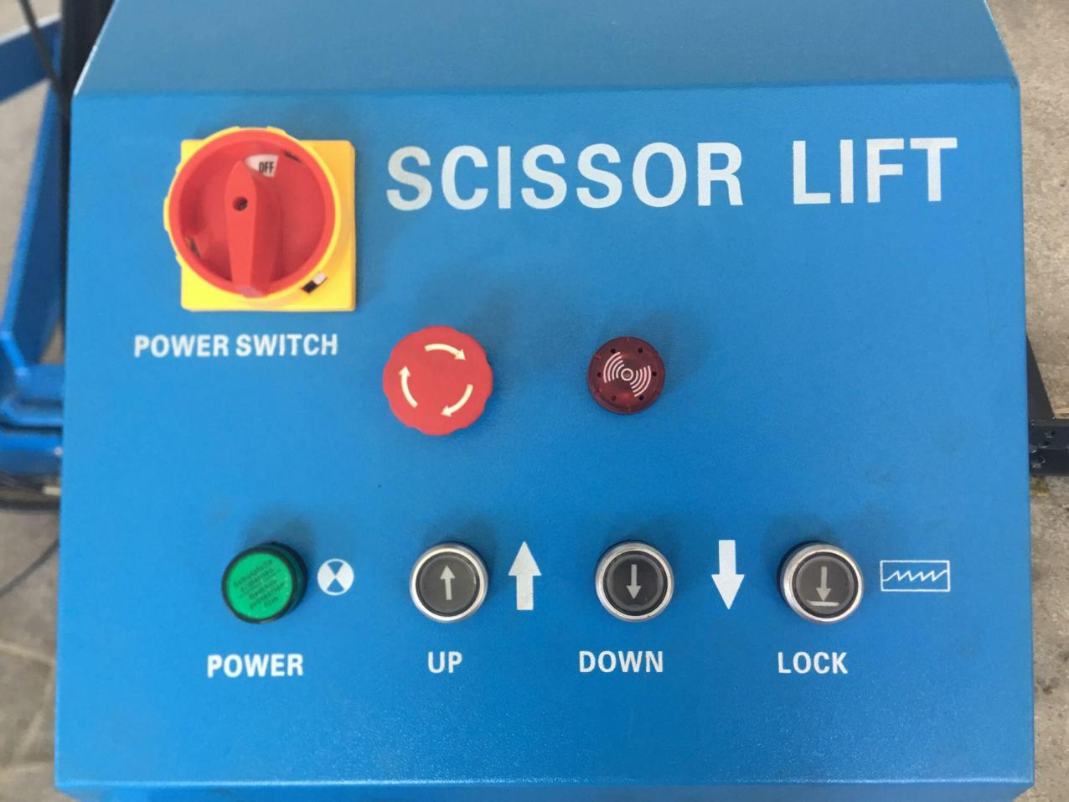

Controls for operating the lift are:

POWER SWITCH
The switch can be set in two positions:
    - 0 position: the lift electric circuit is not powered; the switch can be padlocked to prevent the use of the lift.
    - 1 position: lift electric circuit is powered

LAMP
- It shows that the electric circuit is powered

LIFTING BUTTON
- When pressed, the motor and hydraulic circuit are operated and the lift will be raised

LOWERING BUTTON
- When pressed, the lift will take seconds to release the safety by means of the electromagnets and then the lowering solenoid valve is powered: the lift begins to lower under its weight and the load lifted.

  - To raise the lift
- Position the vehicle at the centre of the platform. Check to make sure that the vehicle

is secured.
- Place the pads in the positions
- Set Power Switch to 1 position
- Press UP button to raise the vehicle
- To rest the lift in standing position at the desired height by releasing UP button.
- Always ensure that the lift rests on the safety before any attempt is made to work on or near the vehicle.

To lower the lift
- Be sure the safety area is free of people and objects;
- Raise the lift a little bit by pushing UP button to clear off the safety;
- Press DOWN button;
- Lower the lift completely

Manual emergency lowering (optional)
In case of no electric power or power unit failure, lower the loaded vehicle manually to its initial position as follows:
Only skilled personnel must be allowed to carry out this operation. An improper operation could cause damages to the safety device.

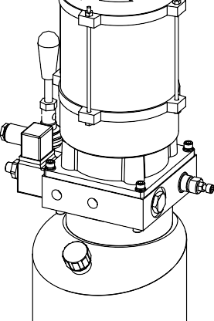
- Padlock the power switch;
- If the safety is engaged, operate the emergency hand pump to raise the lift a little bit to clear off the mechanical safeties.
- Keep pressing the emergency button on the solenoid air valve;
- To lower the lift, unloosen the emergency screw of the lower solenoid valve by turning it anticlockwise. Screwing or unloosing the screw can reduce or increase the lowering speed;
Retighten the emergency screw by turning it clockwise.
After manual lowering of the lift, reset ordinary operating conditions. Lift cannot be lifted if lowering valve is opened.

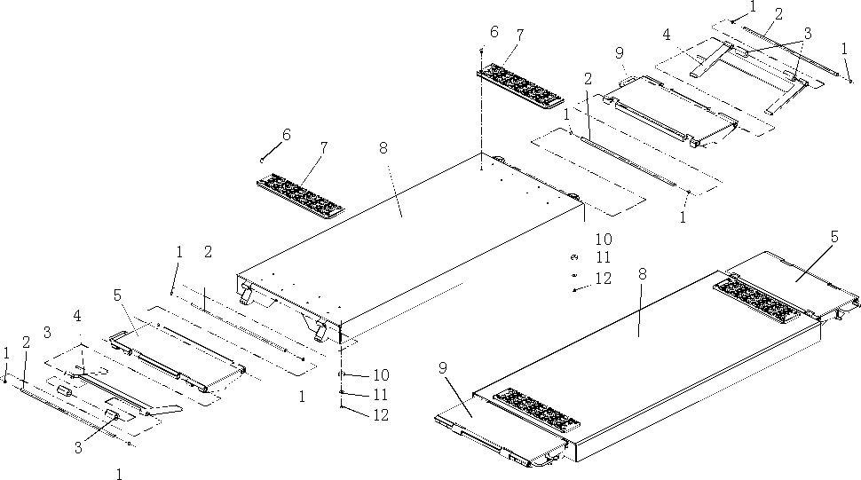

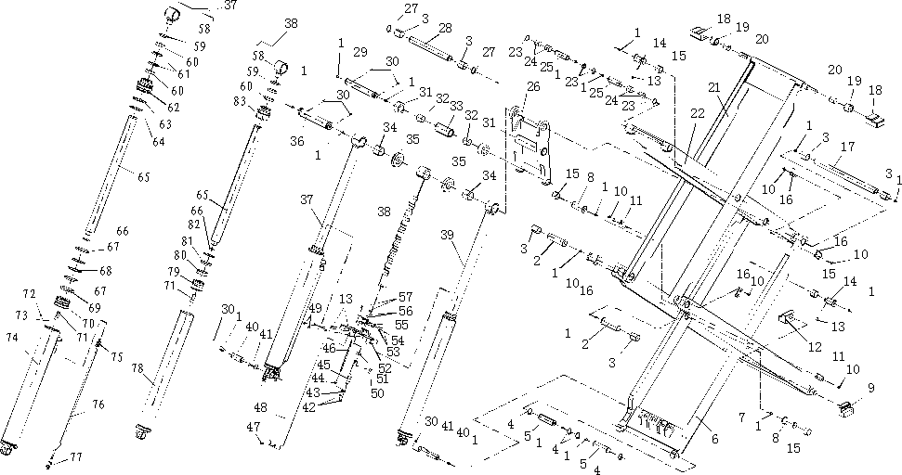

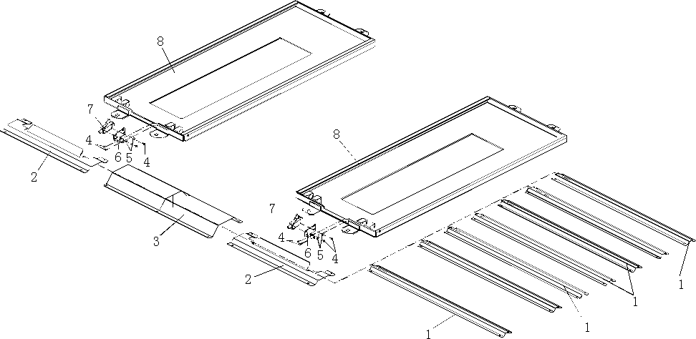

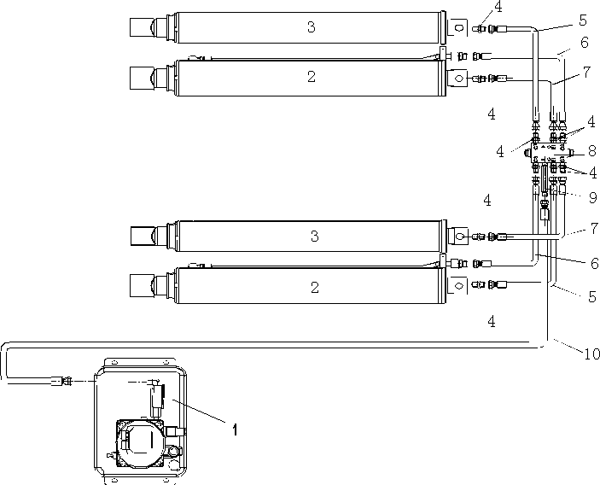

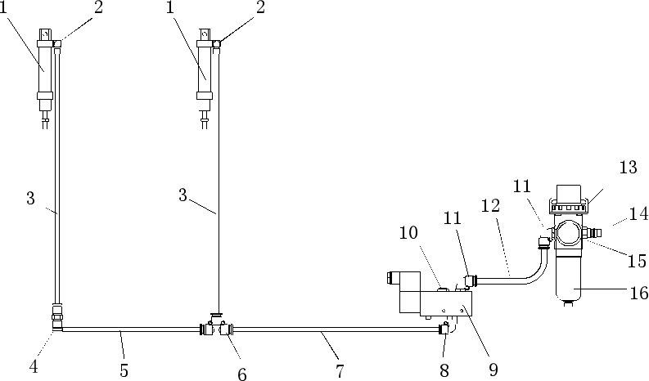

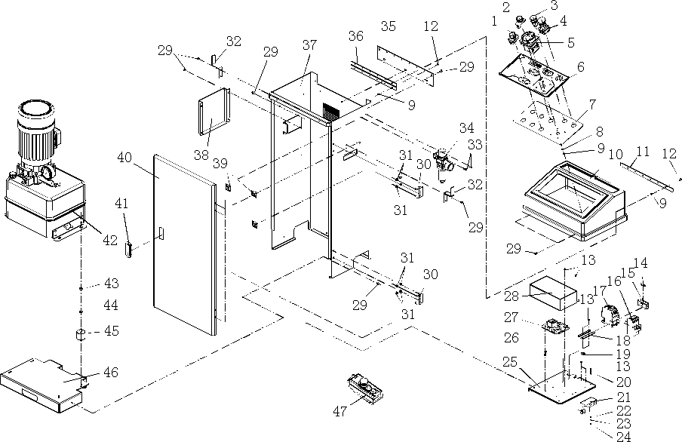

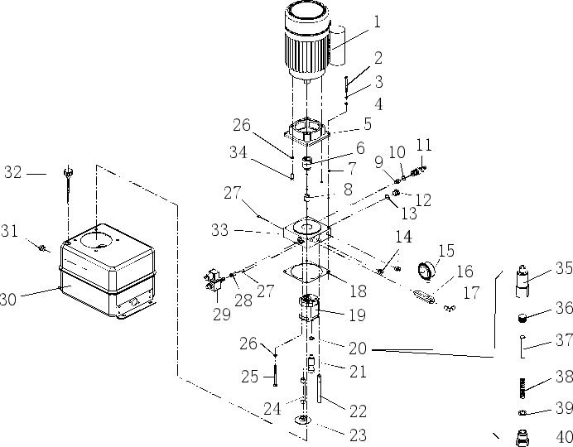

Chapter 7 Maintenance
Turn off and lock the main switch before servicing the lift.
The maintenance intervals indicated below apply to average workshop use. The lift should be inspected more frequently for severe use applications.

Only trained personnel who knows how the lift works must be allowed to service
the lift.

To service properly the lift, the following has to be carried out:
- Use only genuine spare parts as well as equipment suitable for the work required;
- Follow the scheduled maintenance and check periods shown in the manual;
- Discover the reason for possible failures such as too much noise, overheating, oil blow-by, etc.
Refer to documents supplied by the dealer to carry out maintenance:
- Functional drawing of the electric and hydraulic equipment
- Exploded views with all data necessary for spare parts ordering
- List of possible faults and relevant solutions.

Ordinary maintenance
The lift has to be properly cleaned at least once a month using self-cleaning clothes. Lubricate all pivot pins at least once a week. Be sure the rod of the hydraulic cylinders is always clean and not damaged since this may result in leakage from seals and, as a consequence, in possible malfunctions.

  - Periodic maintenance
Every 3 months | Hydraulic circuit | Check oil tank level; refill with oil, if needed; Check the circuit for oil leakage.  Check seals for proper conditions and replac them, if necessary;
 | Foundation bolts | Check bolts for proper tightening
 | Hydraulic pump | Verify that no noise changes take place in th pump when running and check fixing bolts fo proper tightening
 | Safety system | Check safety devices for proper operation
Every 6 months | Oil | Check oil for contamination or ageing Contaminated oil is the main reason for failur of valves and shorter life of gears pumps
Every 12 months | General check | Verify that all components and mechanisms ar not damaged
 | Electrical system | A check of the electrical system to verify tha motor, limit switch and control panel operat properly must be carried out by skille  electricians
 | Oil | Empty the oil tank and change the hydraulic oil

e

e

e e
e d

Chapter 8 Trouble shooting
A list of possible troubles and solutions is given below:

Failure Phenomena | Cause and Phenomena | Resolutions
The motor does not runi n lifting operation. | Connection of power supply wires is not correct. | Check and correct wire connection
 | The AC contactor in the circuit of the motor does not pick up. | If the motor operates when forcing the contactor down with an isolation rod, check the control circuit. If the voltage at two ends of the contactor coil is
 | The limit switch is not closed. | Check the limit switch, wires and  a d j u s t or replace the limit switch.
In lifting operation, th motor runs, but ther is no lifting movement | The motor turns reverse. | Change the phases of the power supply
 | Lifting with light load is normal but no lifting with heavy load. | The set safe pressure of the over-flow valve may be increased by turning the set knob right ward slightly.  The spool of the lowering solenoid valve is stuck by dirt. Clean the spool.
 | The amount of hydraulic oil is not enough. | Add hydraulic oil.
 | The “operation stop valve” is not closed. | Screw  valve”. | down | the | “Operation | stop
When press “Lower button, the machine i not lowered | The safety pawl are not  released form the safety | First lift a little and then lowering
 | The safety pawl is not lifted. | The air pressure is not enough, the safety pawl is stuck or the air pipe is broken off, adjust pressure, check the air pipe and replace it.
 | The solenoid air valve does not work. | If the solenoid air valve is energized, but does not open the air loop, check or replace the solenoid air valve.
 | The lowering solenoid valve is energized but does not work | Check the plug and coil of the lowering solenoid valve and check the right turn tightness of its end copper nut and so on.

 |  | The “antiknock blocked. | valve” | is | Remove the “antiknock valve” from the oil supply hole at the bottom of the oil cylinder, and clean the “antiknock valve”.
Themachine lower extremely slowly under normal loads. |  | The hydraulic oil has too high viscosity or frozen, deteriorated (in Winter). |  |  | Replace with hydraulic oil in accordance with the instruction book.
 |  | The “antiknock valve” for preventing oil pipe burst is blocked. |  |  | Remove or close air supply pipe and thus lock the safety pawl of the machine without lifting of the safety pawl. Remove the “antiknock valve” from the oil supply hole at the bottom
Noisy lifting lowering. | and | Lubrication is not enough. |  |  | Lubricate all hinges and motion parts (including piston rod) with machine oil
 |  | The base or the machine is twisted. |  |  | Adjust again the levelness of the machine, and fill or pad the base.

If the problems remain unsolved, call for technical support.

Chapter 9 Disposal of used oil

Used oil, which is removed from the power unit and the plant during an oil change, must be treated as a polluting product, in accordance with the legal prescriptions of the country in which the lift is installed.

Chapter 10 Machine demolition

The machine must be demolished by authorized technicians, just like for assembling. The metallic parts can be scrapped as iron. In any case, all the materials deriving from the demolition must be disposed of in accordance with the current standards of the country in which the rack is installed. Finally, it should be recalled that for tax purposes, demolition must be documented; submitting claims and documents according to the current laws in the country in which the rack is installed at the time the machine is demolished.

Appendix

Electrical diagram
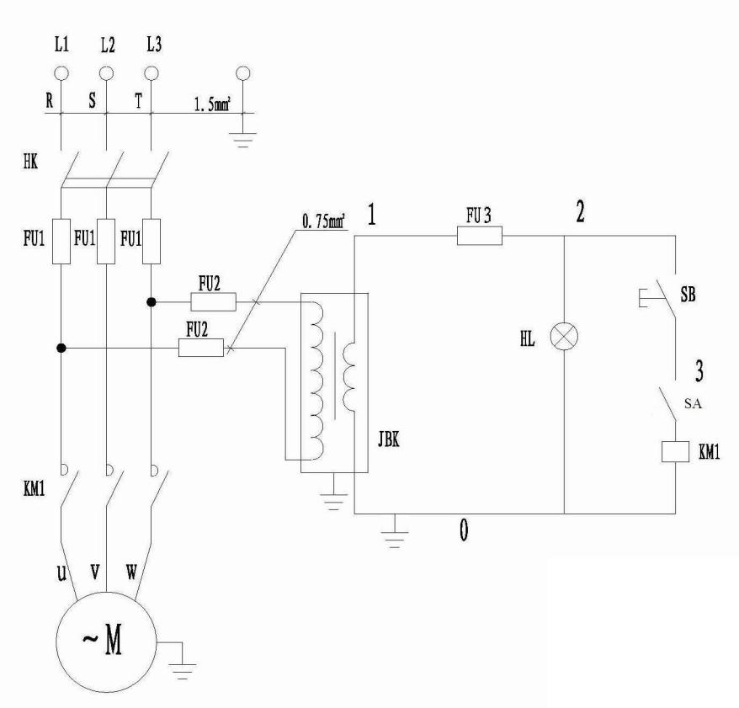

EK: Main switch | FU: Fuse | KM: Contactor | M: Motor
JBK: Transformer | HL: Lamp | SB: UP button | SA: Top limit switch

Hydraulic diagram
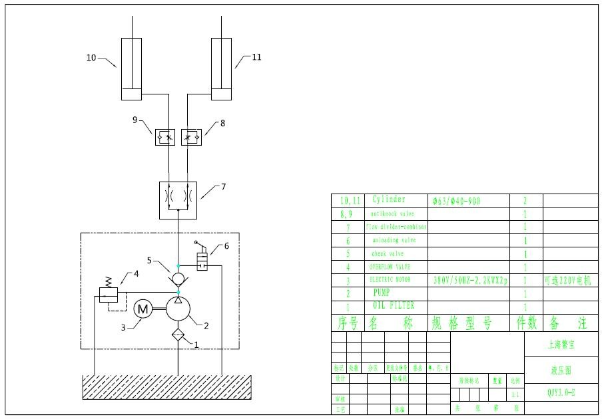

Pneumatic diagram
